Dear RESA Directors,
Below are sample evaluation questions for participants to complete after each of the ten Georgia Paraprofessional Ethics Modules. Feel free to use this one, modify it, or use one of your own.

Please note the following:
- The last slide of the PowerPoint has a place for you to insert an evaluation link. Delete this slide if you don’t plan to use a link for the evaluation.
- At the end of each Facilitator Guide is a place to insert the evaluation or link if you plan to use one.

Paraprofessional Ethics Modules
Evaluation by Module

RESA: __________________________________

School District: _________________________________

Facilitator Name: _______________________________

Date of Session: _______________________________

Use the scale represented below to indicate your level of agreement with each of the following statements. Record the appropriate number in each space (1 = Strongly Disagree through 5 = Strongly Agree).

1 2 3 4 5
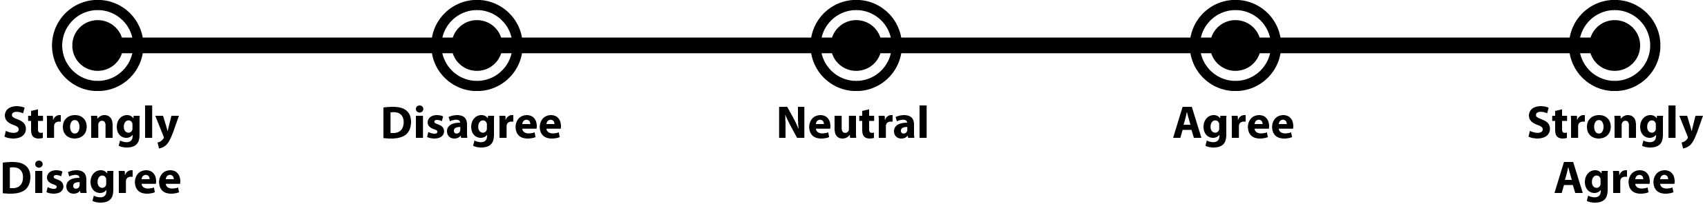

_________ 1. This training will help me in my position to avoid possible violations of the Code of Ethics for Educators.

_________ 2. The training had a strong sequence and flow.
_________ 3. The training session was well organized.
_________ 4. The training session was engaging.
_________ 5. The training offered sufficient opportunities for practice.
_________ 6. The training material was easy to understand.
_________ 7. I achieved the overall learning goals of the training.
_________ 8. The training improved my knowledge in the area.
_________ 9. My skills/knowledge in the professional learning area improved.
_________ 10. The trainer revealed an expertise with the material.
_________ 11. I would recommend this training to a colleague.

Please provide any additional feedback below on this professional learning training you would like to share.

